- Difference bw string, StringBuilder and String buffer? Why String is immutable ?
Ans)

Feature | String | StringBuilder | StringBuffer
Mutable | ❌ No | ✅ Yes | ✅ Yes
Thread-safe | ✅ (immutable by nature) | ❌ No | ✅ Yes
Performance | Slow when concatenating repeatedly | Fastest | Slower than StringBuilder
Memory | Creates new object on modification | Same object reused | Same object reused

String is immutable, so every modification creates a new object. StringBuilder and StringBuffer are mutable, allowing changes to the same object. The main difference is that StringBuilder is not synchronized, making it faster and suitable for single-threaded applications, whereas StringBuffer is synchronized, making it thread-safe but slightly slower. In most modern Java applications, including Selenium automation, StringBuilder is the preferred choice unless thread safety is specifically required.

Java made String immutable for several reasons: security, String Pool optimization, thread safety, and stable hash codes for collections like HashMap. Because a String cannot be modified after creation, multiple references can safely share the same object, sensitive values cannot be altered unexpectedly, and the JVM can optimize memory usage and performance.

- JDK vs JRE vs JVM
Ans) JDK is a software development kit used to develop, compile, debug, and run Java applications. It contains the JRE along with development tools such as javac, java, javadoc, and jar.
Example- When I write Java code, the JDK provides the compiler (javac) to convert .java files into .class files.

JRE provides the environment required to run Java applications. It contains the JVM and Java class libraries but does not include development tools like the Java compiler.
Example- If a user only wants to run a Java application, they need JRE, not the full JDK.
JVM- JVM is a virtual machine that executes Java bytecode. It converts bytecode into machine code using the Just-In-Time (JIT) compiler, making Java platform independent.
.java
↓
javac (JDK Compiler)
.class (Bytecode)
↓
JVM
↓
Machine Code
- Class Vs Object ?
Ans) A class is a blueprint or template that defines the properties (fields) and behavior (methods) of an object.
An object is a real-time instance of a class that occupies memory and can access the properties and methods defined in the class.
- Method Overloading and Overriding ?
Ans) Method overloading means creating multiple methods with the same name but different parameter lists within the same class. It is an example of compile-time polymorphism.
add(int a,int b)
add(double a,double b)

Method overriding means redefining a superclass method in the child class with the same method signature to provide a different implementation. It is an example of runtime polymorphism.
class Animal{
void sound(){}
}

class Dog extends Animal{
@Override
void sound(){}
}
- Can we override static methods?
No. Static methods belong to the class, not the object. They are hidden, not overridden.
- Static keyword- The static keyword indicates that a member belongs to the class rather than to an object. Static members are shared among all objects, and only one copy exists regardless of how many objects are created.

- Final- The final keyword is used to restrict modification.
A final variable cannot be reassigned.
A final method cannot be overridden.
A final class cannot be inherited.
- This- this refers to the current object of the class. It is used to access instance variables, invoke methods, or call another constructor of the same class.
- Super- refers to the immediate parent class. It is used to access parent class variables, methods, or constructors.
- Constructor- A constructor is a special member of a class that is automatically invoked when an object is created. It is primarily used to initialize objects.
- OOPS concept- Object, Class, Inheritance, Polymorphism, Abstraction, Encapsulation
Ans) Java OOP(Object Oriented Programming) Concepts - GeeksforGeeks
- Explain LinkedhashSet and Set?
Ans) Set- Is an interface in Java collection framework.
- Duplicate elements are not allowed.
- Insertion order not preserved
- Can contains null based on the implementation
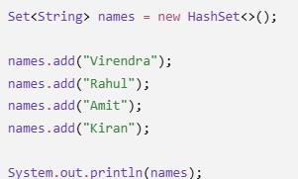
HashSet- Is a class that implements Set
- Underlying structure is HashTable
- Duplicates not allowed
- Insertion Order not preserved (No Order)
linkedHashSet- Is a class that implements Set, it’s a child class of Hashset.
- Underlying structure is HashTable + LinkedList.
- Remove the duplicate elements
- Insertion Order Preserved
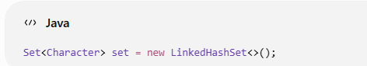
- ArrayList Vs LinkedList ?
Ans)
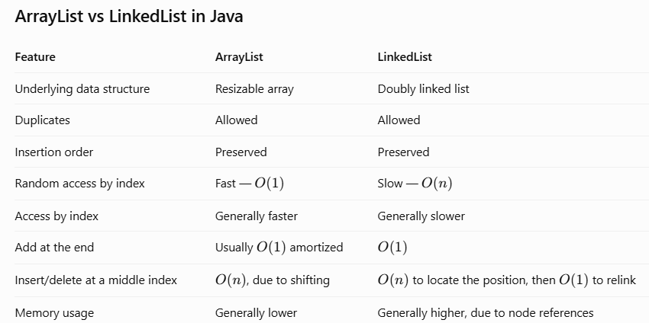
- HashMap, hashSet and concurrentHashMap?
Ans)
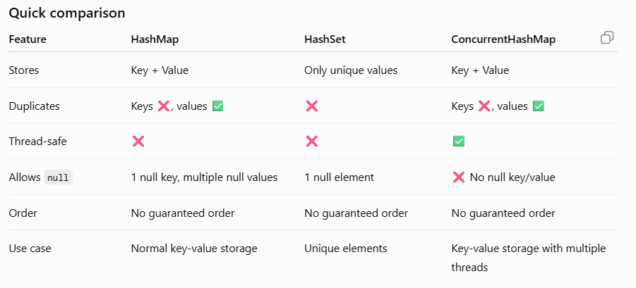
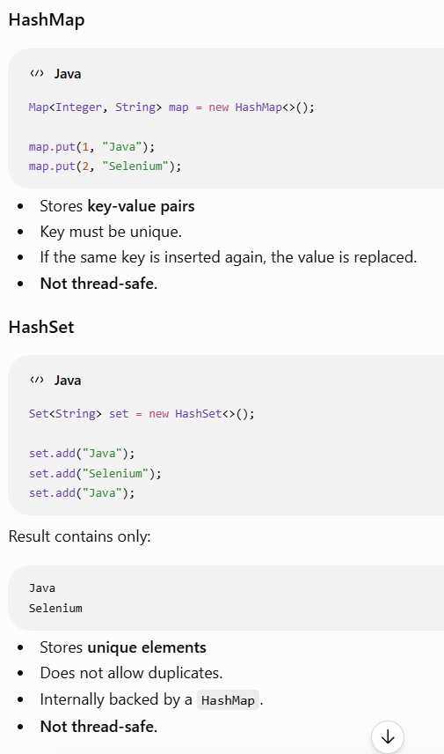
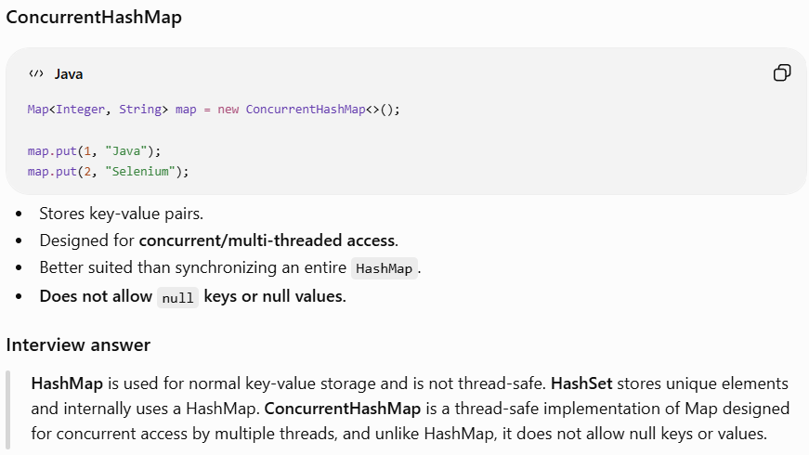
- Comparable and comparator ?
Ans)
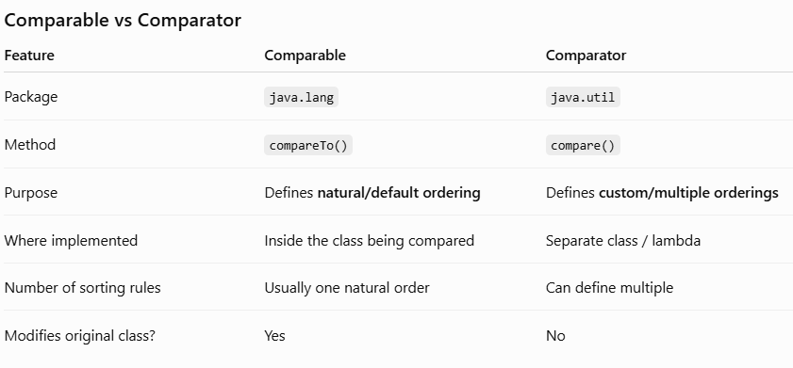
Comparable is used to define the natural ordering of objects. The class implements Comparable and overrides the compareTo() method.
Comparator is used when we need custom sorting logic. It is implemented separately from the class and uses the compare() method.
Q: When would you use Comparator instead of Comparable?
"I would use Comparator when the class needs multiple sorting criteria or when I don't want to modify the original class. For example, an Employee can have natural ordering by ID using Comparable, while Comparator can provide sorting by name, salary, or department."
- Why String is immutable ?
Ans) String is immutable in Java for security, memory optimization, thread safety, and reliable hash-code behavior.
Since strings cannot be modified after creation, Java can safely reuse string literals through the String Constant Pool. Immutability also makes strings safe to share across threads and reliable as keys in collections such as HashMap.
Whenever we perform an operation such as concatenation, Java creates a new String object rather than modifying the existing object.
- Why do we use an interface ?
Ans) 1. Abstraction
An interface defines what a class must do, without specifying how it does it.
2. Loose coupling
The code depends on an interface rather than a specific implementation. This makes it easier to replace one implementation with another.
3. Multiple inheritance of type
A Java class can implement multiple interfaces, allowing it to follow multiple contracts.
4. Standardization
Different classes can provide their own implementations of the same methods defined by an interface.
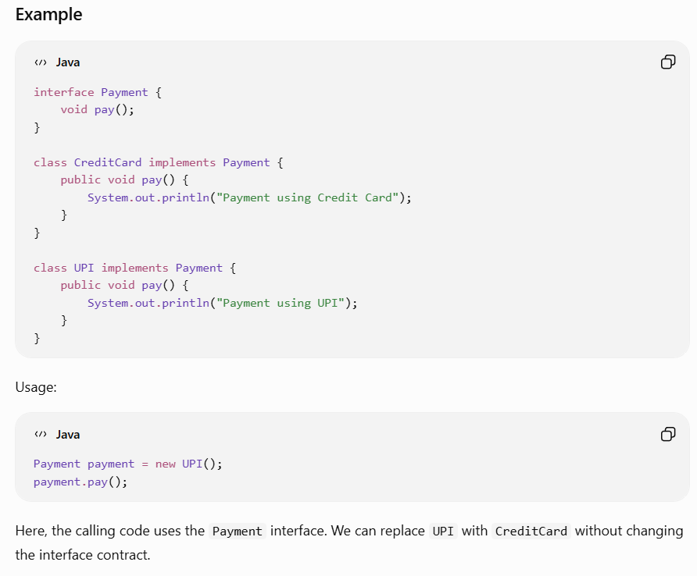
- Why does Java not support multiple inheritance with classes?
Ans) Java does not allow a class to extend multiple classes because it can create ambiguity when both parent classes contain methods with the same signature. The compiler cannot determine which implementation the child class should inherit.
- Which OOP concept did you use in your framework?
Ans) I have used all 4 OOPS principle in my framework.
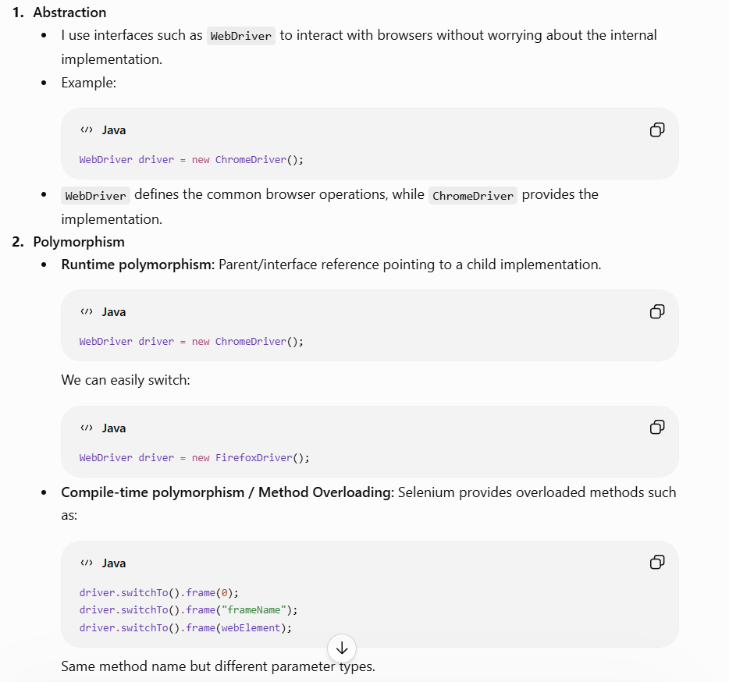
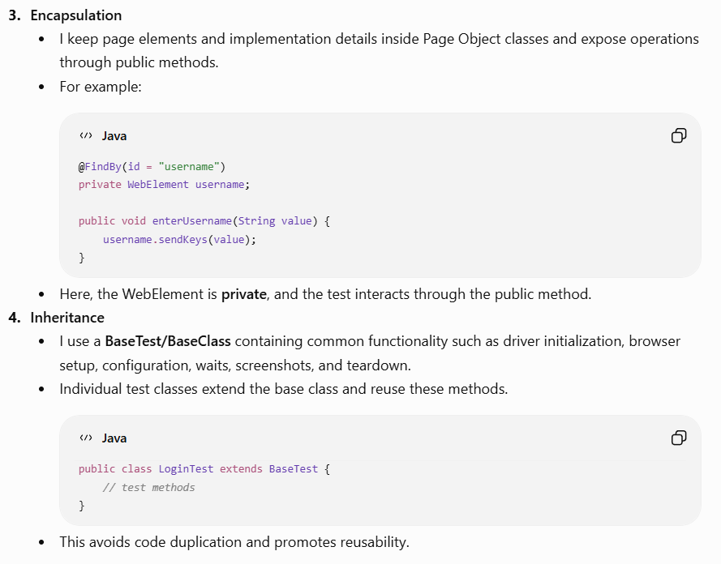
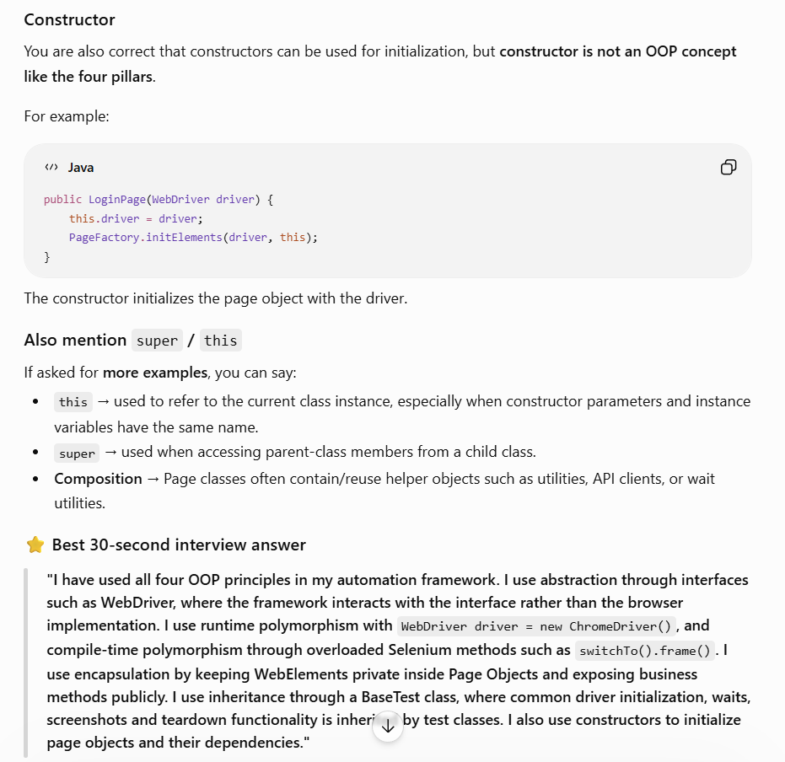
- Can you instantiate an interface directly ?
Ans) No, we can not instantiate interface directly.
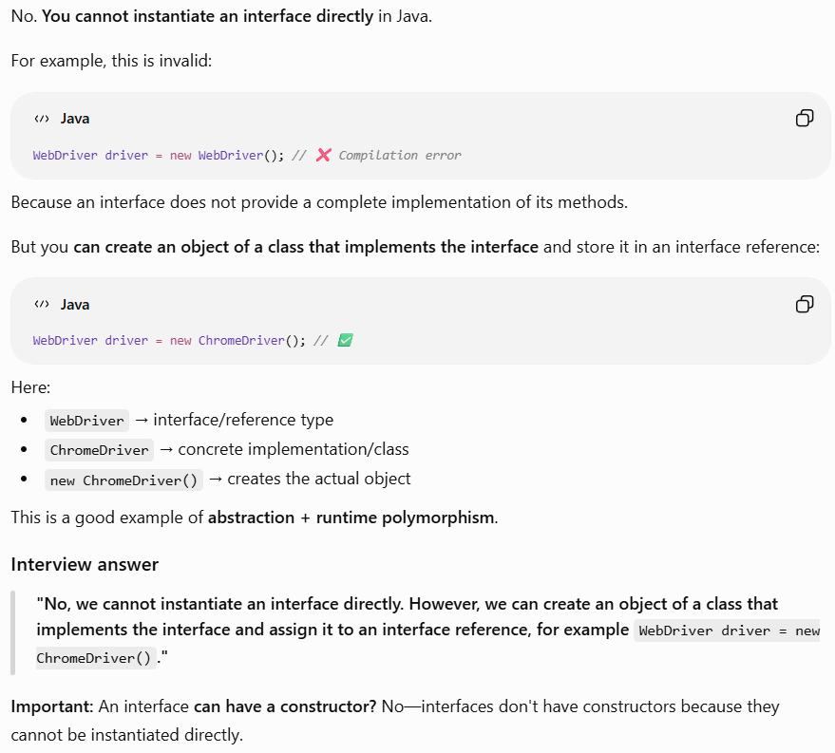
- Can you call an unimplemented interface method ?
Ans)
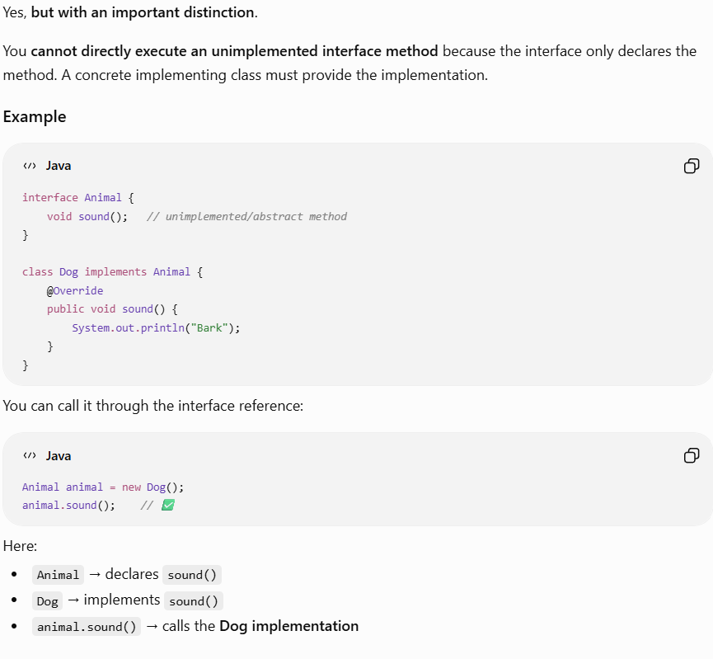
- Can Static method be overload and override ?
Ans) Static methods can be overloaded because overloading is based on the method signature and is resolved at compile time. Static methods cannot be overridden because they belong to the class rather than the object. If a child class defines a static method with the same signature, it is called method hiding, not method overriding.
